**Student Name: Rishav Kumar UID:22MCC20039 Section/Group: 22MCD-1 (A) Semester: 2nd**

**Branch: MCA-CC &DevOps Date of Submission: 11-05-2023**

**Subject: Advanced Internet Programming Lab Subject Code: 22CAP-686**

**Experiment No. 7**

Write the simple program in Hibernate.

1. **Aim/Overview of the practical:**

Create one simple program in Hibernate.

**Task to be done:**

Create one simple program in Hibernate.

1. **Algorithm/ Flowchart:**

**Step 1:** Create one java application with name Exp1.

**Step 2:** Now right click on **source package>>new>>others** and then select hibernate and select hibernate configuration wizard and select database and click on finish.

**Step 3:** Right click on default **package>>new>>others** and then select hibernate and select hibernate reverse engineering wizard. Then select available table employee and click on add.

**Step 4:** Right click on source **package>>new>>java package** (with name POJO).

**Step 5:** Now right click on **POJO>>new>>other** and then click on hibernate and select hibernate mapping files and POJO’s from database.

**Step 6:** Create one more package with name connection. right click on **connection>>new>>other** and then click on hibernate and select HibernateUtil.java.

**Step 7:** And now create one file and write simple code to insert data.

1. **Code for experiment/practical:**

**Hibernate mapping files class (Employee class):**

package POJO;

public class Employee implements java.io.Serializable {

private int empId;

private String empName;

private Integer empSalary;

public Employee() {

}

public Employee(int empId) {

this.empId = empId;

}

public Employee(int empId, String empName, Integer empSalary) {

this.empId = empId;

this.empName = empName;

this.empSalary = empSalary;

}

public int getEmpId() {

return this.empId;

}

public void setEmpId(int empId) {

this.empId = empId;

}

public String getEmpName() {

return this.empName;

}

public void setEmpName(String empName) {

this.empName = empName;

}

public Integer getEmpSalary() {

return this.empSalary;

}

public void setEmpSalary(Integer empSalary) {

this.empSalary = empSalary;

}

}

**EmployeeDB:**

package connection;

import POJO.Employee;

import org.hibernate.Session;

import org.hibernate.Transaction;

/**

*

* @author Anshul

*/

public class EmployeeDB {

static Session session=null;

public static void insert(Employee e){

session=Controller.getSessionFactory().openSession();

Transaction tx=session.beginTransaction();

session.save(e);

tx.commit();

}

public static void main(String[] args){

Employee E1=new Employee(20011,"Anshul Gupta",15000);

insert(E1);

}

}

1. **Result/Output/Writing Summary:**

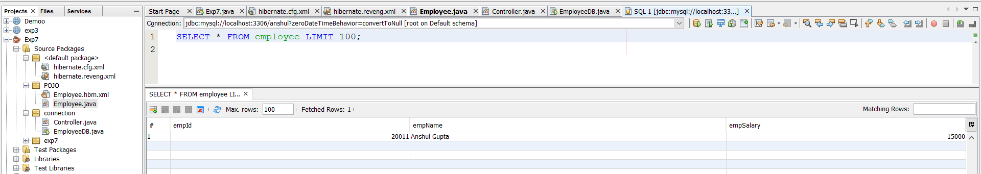

**Learning outcomes:**

**1.** Learn to implement Hibernate in Netbeans.

**2.** Learn to insert record using Hibernate.